Bicycle mass production confirmation
自行车生产确认
Project name  项目名称 | Go bike | Quantity  数量 | White and orange：5  White and blue：5  Black and yellow：5  Black and green：5
Frame colour  车架颜色 | Black and white | Color Number  色号 | black：YS728  white：YS701
Tire size  轮胎尺寸 | 26*2.125 | Lock  是否带锁 | No
Design drawing  效果图 | 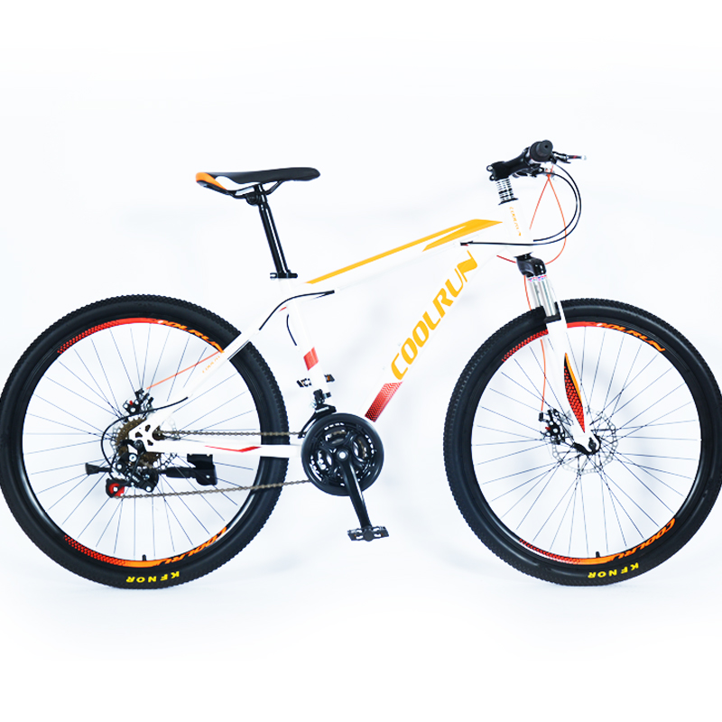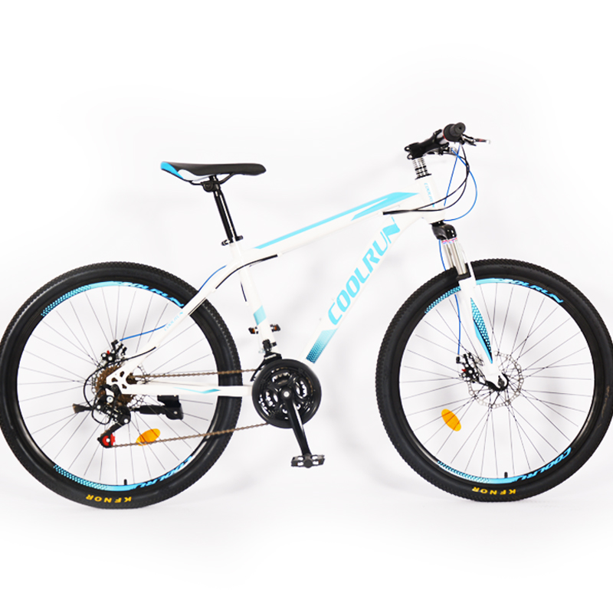  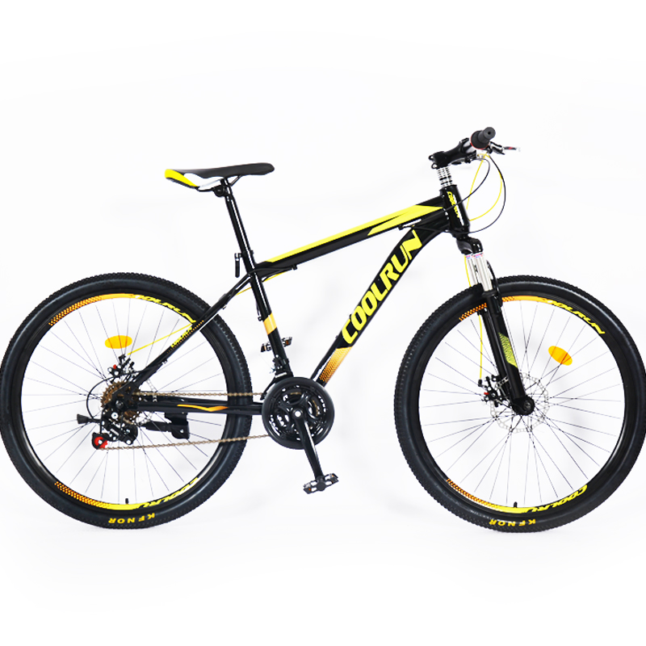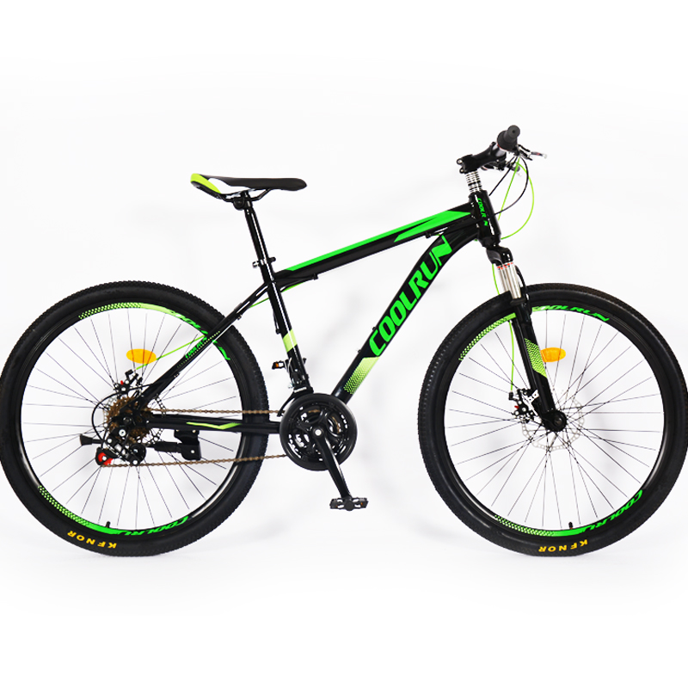
Main configuration description  主要配置描述 | - 26*2.125  - steel frame  - steel suspension fork  - 21 speed  - Disc brakes
Owner's opinion  意见 | Stamp： Signature：  盖章 签名
Mark  备注 | This form is a confirmation form for the final mass production of bicycles. Please check the signature of the seal and send it back.  此表格是最终量产自行车的确认书。请核对一下印章、签名并寄回。

2019-6-25

